**Assignment -1**

|  |  |
| --- | --- |
| Team ID | PNT2022TMID03497 |
| Maximum Marks | 2 Marks |

**Question-1:**

Split this string

**Solution:**

s = "Hi there Sam!"

print(s.split())

#----------------------------------------#

#----------------------------------------#



**Question-2:**

Use .format() to print the following string.

Output should be: The diameter of Earth is 12742 kilometers**.**

**Solution:**

planet = "Earth"

diameter = 12742

txt="The diameter of {plt} is {dr} kilometres.".format(plt=planet,dr=diameter)

print(txt)

#----------------------------------------#

#----------------------------------------#

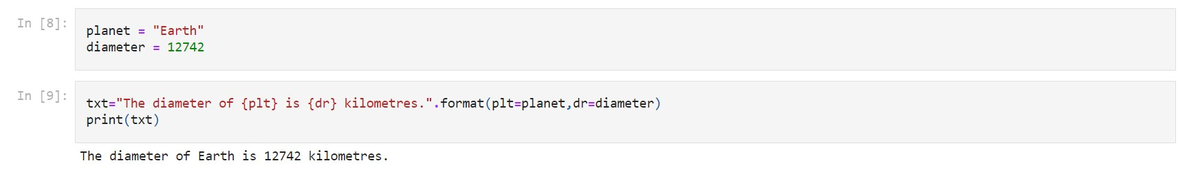

**Question 3:**

In this nest dictionary grab the word "hello"

Solution:

|  |  |
| --- | --- |
|  | d = {'k1':[1,2,3,{'tricky':['oh','man','inception',{'target':[1,2,3,'hello']}]}]} |
|  |  |
|  |  |

**Question 4.1:**

Create an array of 10 zeros?

Solution:

|  |  |
| --- | --- |
|  | import numpy as np |
|  | array=np.zeros(10) |
|  | print(array) |

Question4.2:

Create an array of 10 fives?

Solution:

import numpy as np array=np.ones(10)*5print(array)

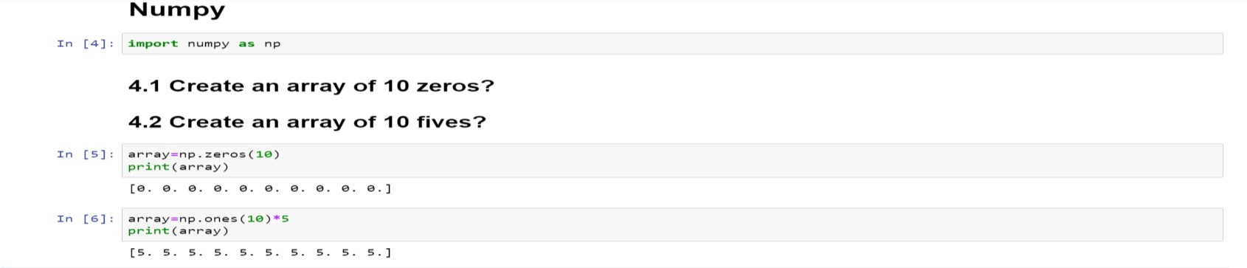

**Question 5:**

Create an array of all the even integers from 20 to 35

Solution:

array=np.arange(20,35,2) print(array)

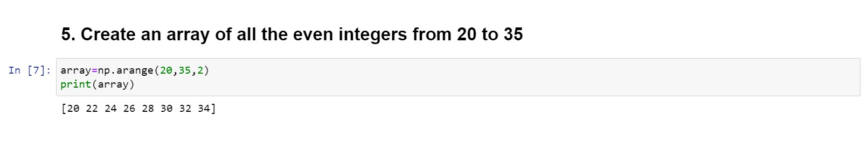

**Question 6:**

Create a 3x3 matrix with values ranging from 0 to 8

Solution:

arr=np.arange(0,9).reshape(3,3) print(arr)

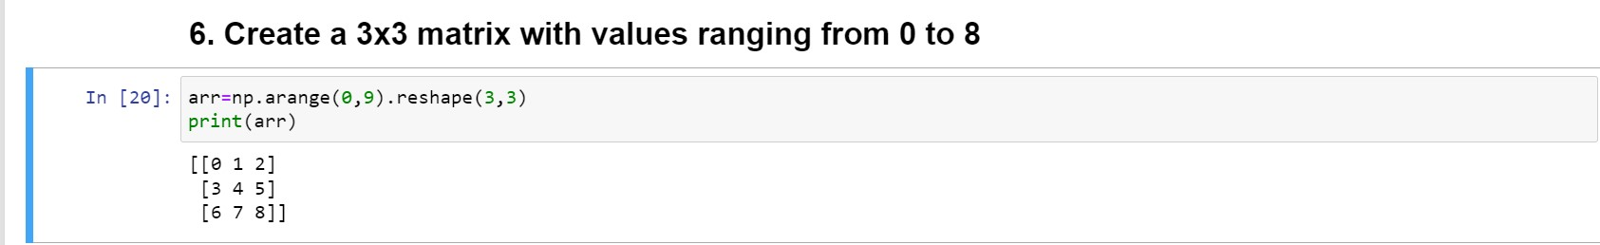

**Question 7:**

Concatinate a and b a = np.array([1, 2, 3]), b = np.array([4, 5, 6])

Solution:

a=np.array([1,2,3]) b=np.array([4,5,6]) np.concatenate([a,b])

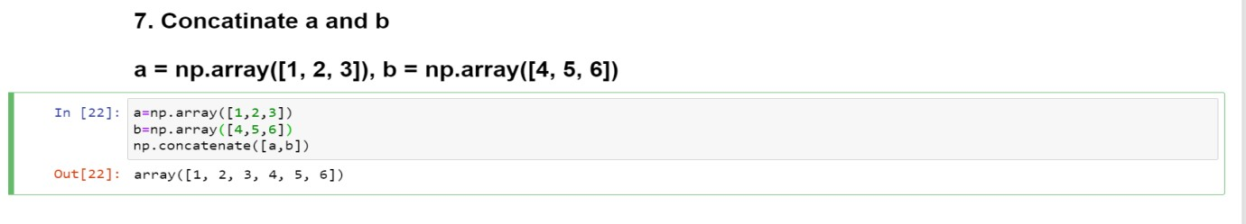

**Question 8:**

Create a dataframe with 3 rows and 2 columns

Solution:

import pandas as pd

data=pd.DataFrame(index=np.arange(3), columns=np.arange(2))

print(data)

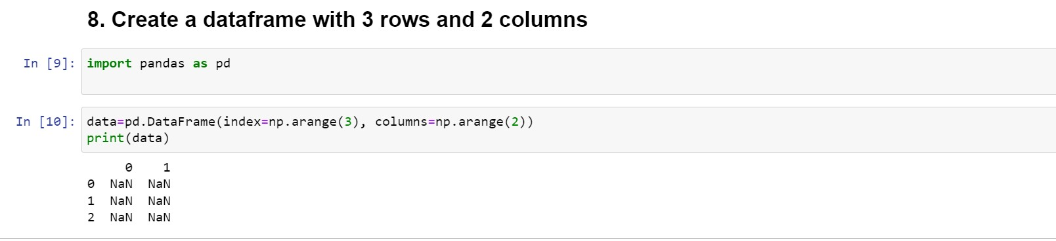

**Question 9:**

Generate the series of dates from 1st Jan, 2023 to 10th Feb, 2023

Solution:

data=pd.date_range(start="1/1/2023",end="10/2/2023") print(data)

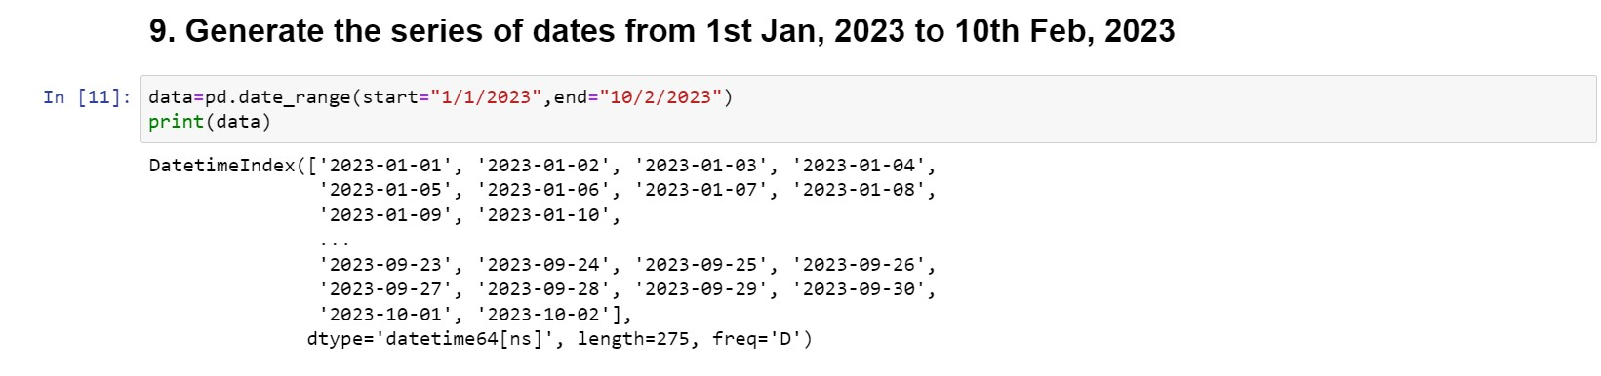

**Question 10:**

Create 2D list to DataFrame

lists = [[1, 'aaa', 22], [2, 'bbb', 25], [3, 'ccc', 24]]

Solution:

lists = [[1, 'aaa', 22], [2, 'bbb', 25], [3, 'ccc', 24]]

data=pd.DataFrame(lists,columns=["s.no","pattern","number"])print(data)

